**Derive Points table for ICC Tournament**

**Take the below table as input and calculate the points table for the tournament.**

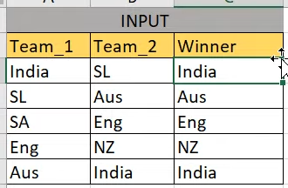

**Output**

